001-generic-relationship-1

chapter01$
MATCH (n {id:"0eLgWXRdFvQWb5Ch6Hm33Z"})-[:HAS_TRACK]->(t:Track)
-[:ARTIST]->(a:Artist) //this n matches an album
RETURN t.name AS trackName, a.name AS artistName

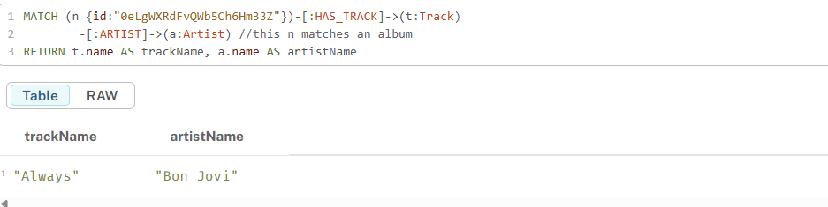

002-generic-relationship-2

chapter01$
MATCH (t:Track {id: "0kish3Tobj6Wq0we74343q"})<-[:HAS_TRACK]-(n)
RETURN n.name, labels(n)

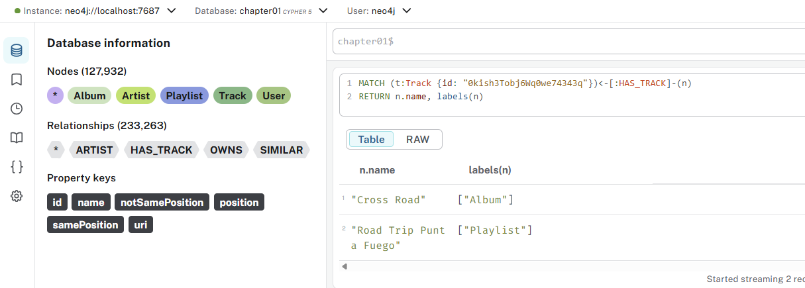

003-generic-relationship-3

chapter01$
MATCH (t:Track {id:"15vzANxN8G9wWfwAJLLMCg"})<-[:HAS_TRACK]-(a:Album)
RETURN t,a

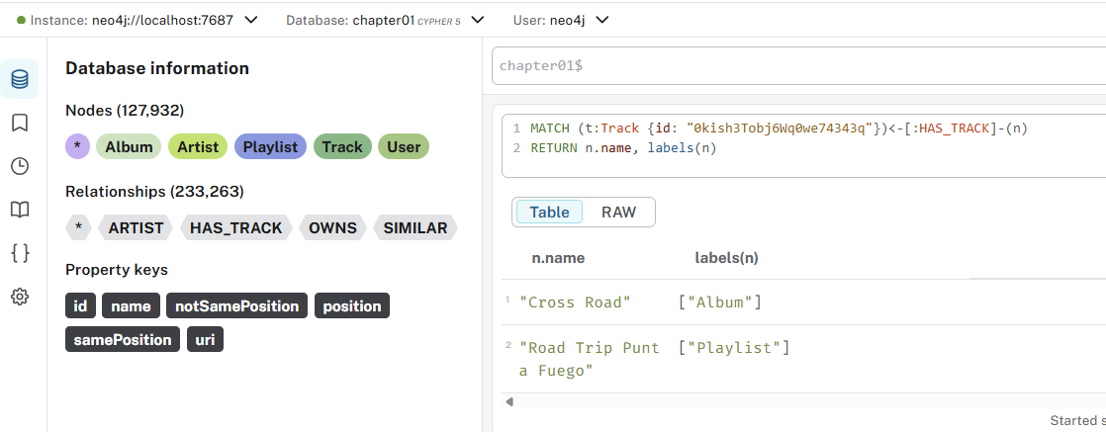

004-find-similar

chapter01$
MATCH (a:Playlist)-[:SIMILAR]-(b:Playlist)
RETURN a,b

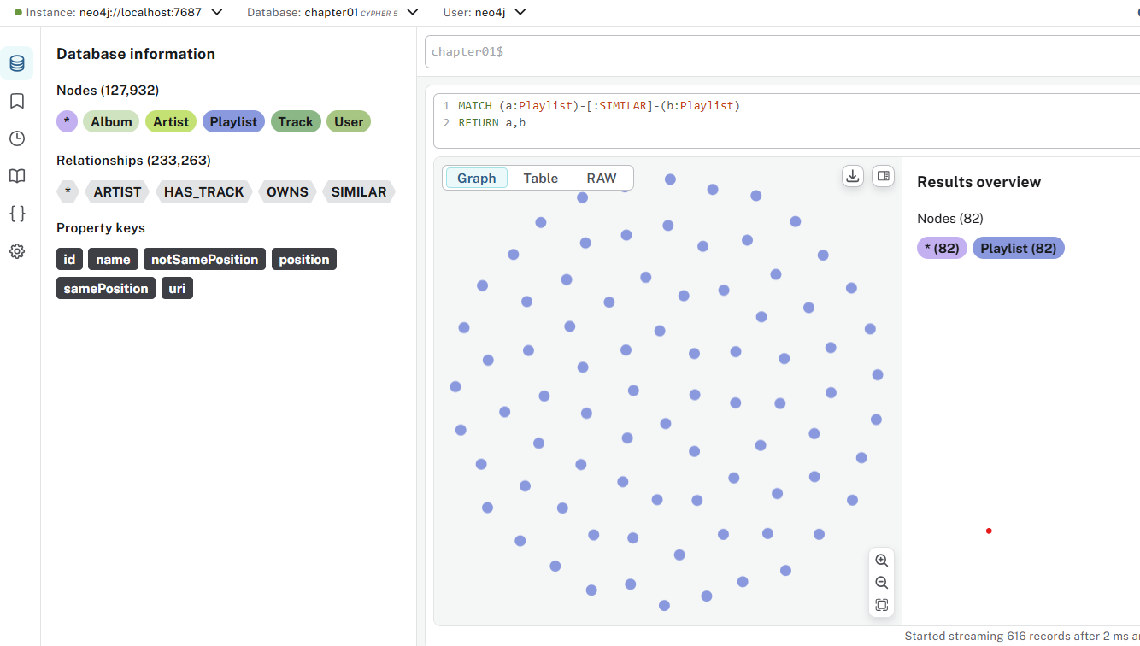

005-double-traversal

chapter01$
MATCH path=(track1:Track {id:"0BB9eUBBaaX6GALSYNcEp7"})-[*3]-(track2:Track {id:"2KmEgiY8fQs0G6WNxtzQKr"})
RETURN path

- [*] means "any number of relationships/hops"
- [*3] means "exactly 3 relationships/hops"
- So the pattern will match paths where there are exactly 3 relationships between track1 and track2

What does this query do:
- Finds all paths that connect these two specific tracks
- Each path must have exactly 3 relationships (edges) between them
- The path could go through other nodes (likely other tracks, artists, albums, etc.)

Other examples of variable-length relationships:
- [*1..3] = 1 to 3 hops
- [*..5] = up to 5 hops
- [*3..] = 3 or more hops
- [*] = any number of hops

In your music graph context, this might find connections like:
- Track1 → Artist → Album → Track2
- Track1 → Genre → Playlist → Track2
- Or any other 3-step path through the graph structure

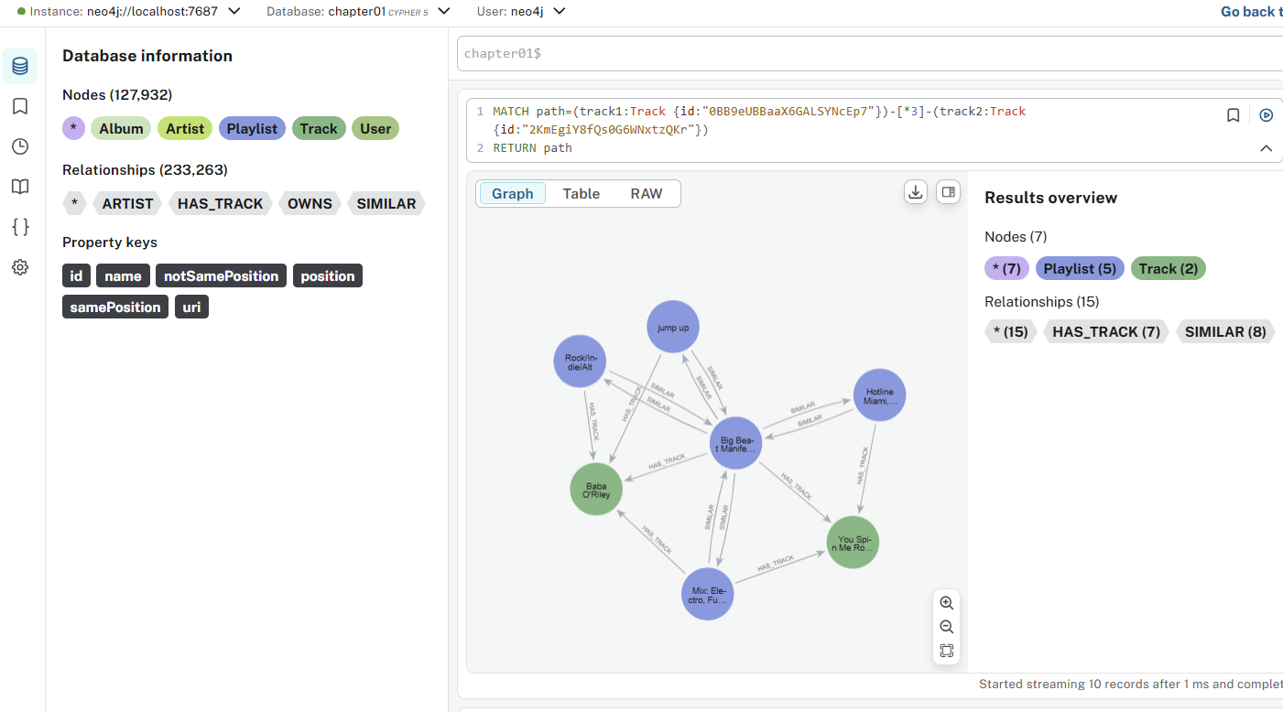

006-drop-similar

chapter01$
MATCH ()-[r:SIMILAR]-()
DELETE r

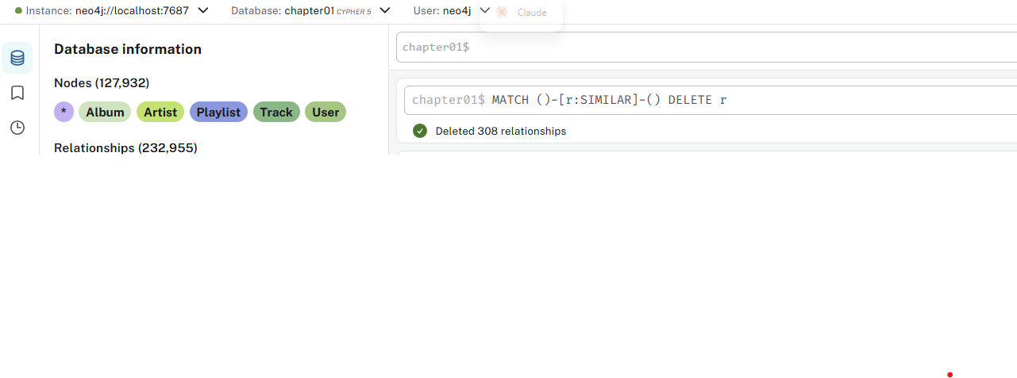

007-single-similar-rel

chapter01$
MATCH path=(p:Playlist)-[r1:HAS_TRACK]->(track)<-[r2:HAS_TRACK]-(other:Playlist)
WITH p AS playlistLeft, other AS playlistRight, collect({track: track, positionLeft: r1.position, positionRight: r2.position}) AS commonTracks
WHERE size(commonTracks) > 5
WITH playlistLeft, playlistRight, size([track in commonTracks WHERE track.positionLeft = track.positionRight]) AS tracksWithSamePosition,
size([track in commonTracks WHERE NOT track.positionLeft = track.positionRight]) AS tracksAtDifferentPosition
MERGE (playlistLeft)-[r:SIMILAR]-(playlistRight)
SET r.samePosition = tracksWithSamePosition, r.notSamePosition = tracksAtDifferentPosition

